
Joint Research Centre


Agenda

Non-indigenous species: progress across MSFD criteria
Implementing D2 measures, enhancing monitoring efforts, and the assessing D2C2 and D2C3 criteria for marine biodiversity protection.
Casa Don Guanella Barza / Ispra
10-12 February 2025

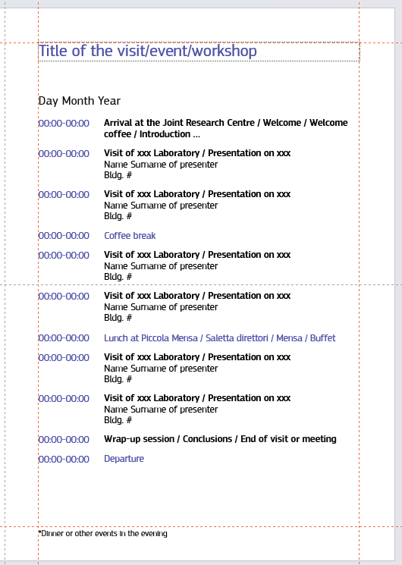
Non-indigenous species (NIS): progresses across MSFD criteria

10 February 2025
13:30-13:45 | Arrival at Casa Don Guanella
13:45-14:00 | Welcome participants and adoption the agenda
14:00-16:00 | Item 1: Matters rising from the JRC work on MSFD monitoring programme and related effort: avenues for improvement and current application
16:00-16:30 | Coffee break
16:30-17:30 | Discussion
17:30-18:00 | Conclusions and next steps

Non-indigenous species (NIS): progresses across MSFD criteria

11 February 2025
09:00-09:15 | Welcome participants and adoption the agenda
09:15-10:45 | Item 2: Matters rising from the JRC work on NIS measures and target: avenues for improvement and current application.
10:45-11:15 | Coffee break
11:15-12:00 | Item: continuation
12:00-13:00 | Discussion
13:00-14:00 | Lunch at Don Guanella
14:00-16:00 | Item 3: Matters rising from the JRC work on distribution of NIS with adverse effects on species groups and habitat types.
16:00-16:30 | Coffee break
16:30-17:30 | Discussion
17:30-18:00 | Conclusions and next steps
20:00-23:00 | Social Dinner

Non-indigenous species (NIS): progresses across MSFD criteria

12 February 2025
09:00-09:15 | Welcome of participants and adoption of the agenda
09:15-10:45 | Item 4: Matters rising from the JRC work on impact of NIS on species groups and habitat types.
10:45-11:15 | Coffee break
11:15-12:00 | Item 4: continuation
12:00-13:00 | Discussion and next steps.
13:00-14:00 | Lunch at Don Guanella
14:00-14:30 | End of the meeting-departure

